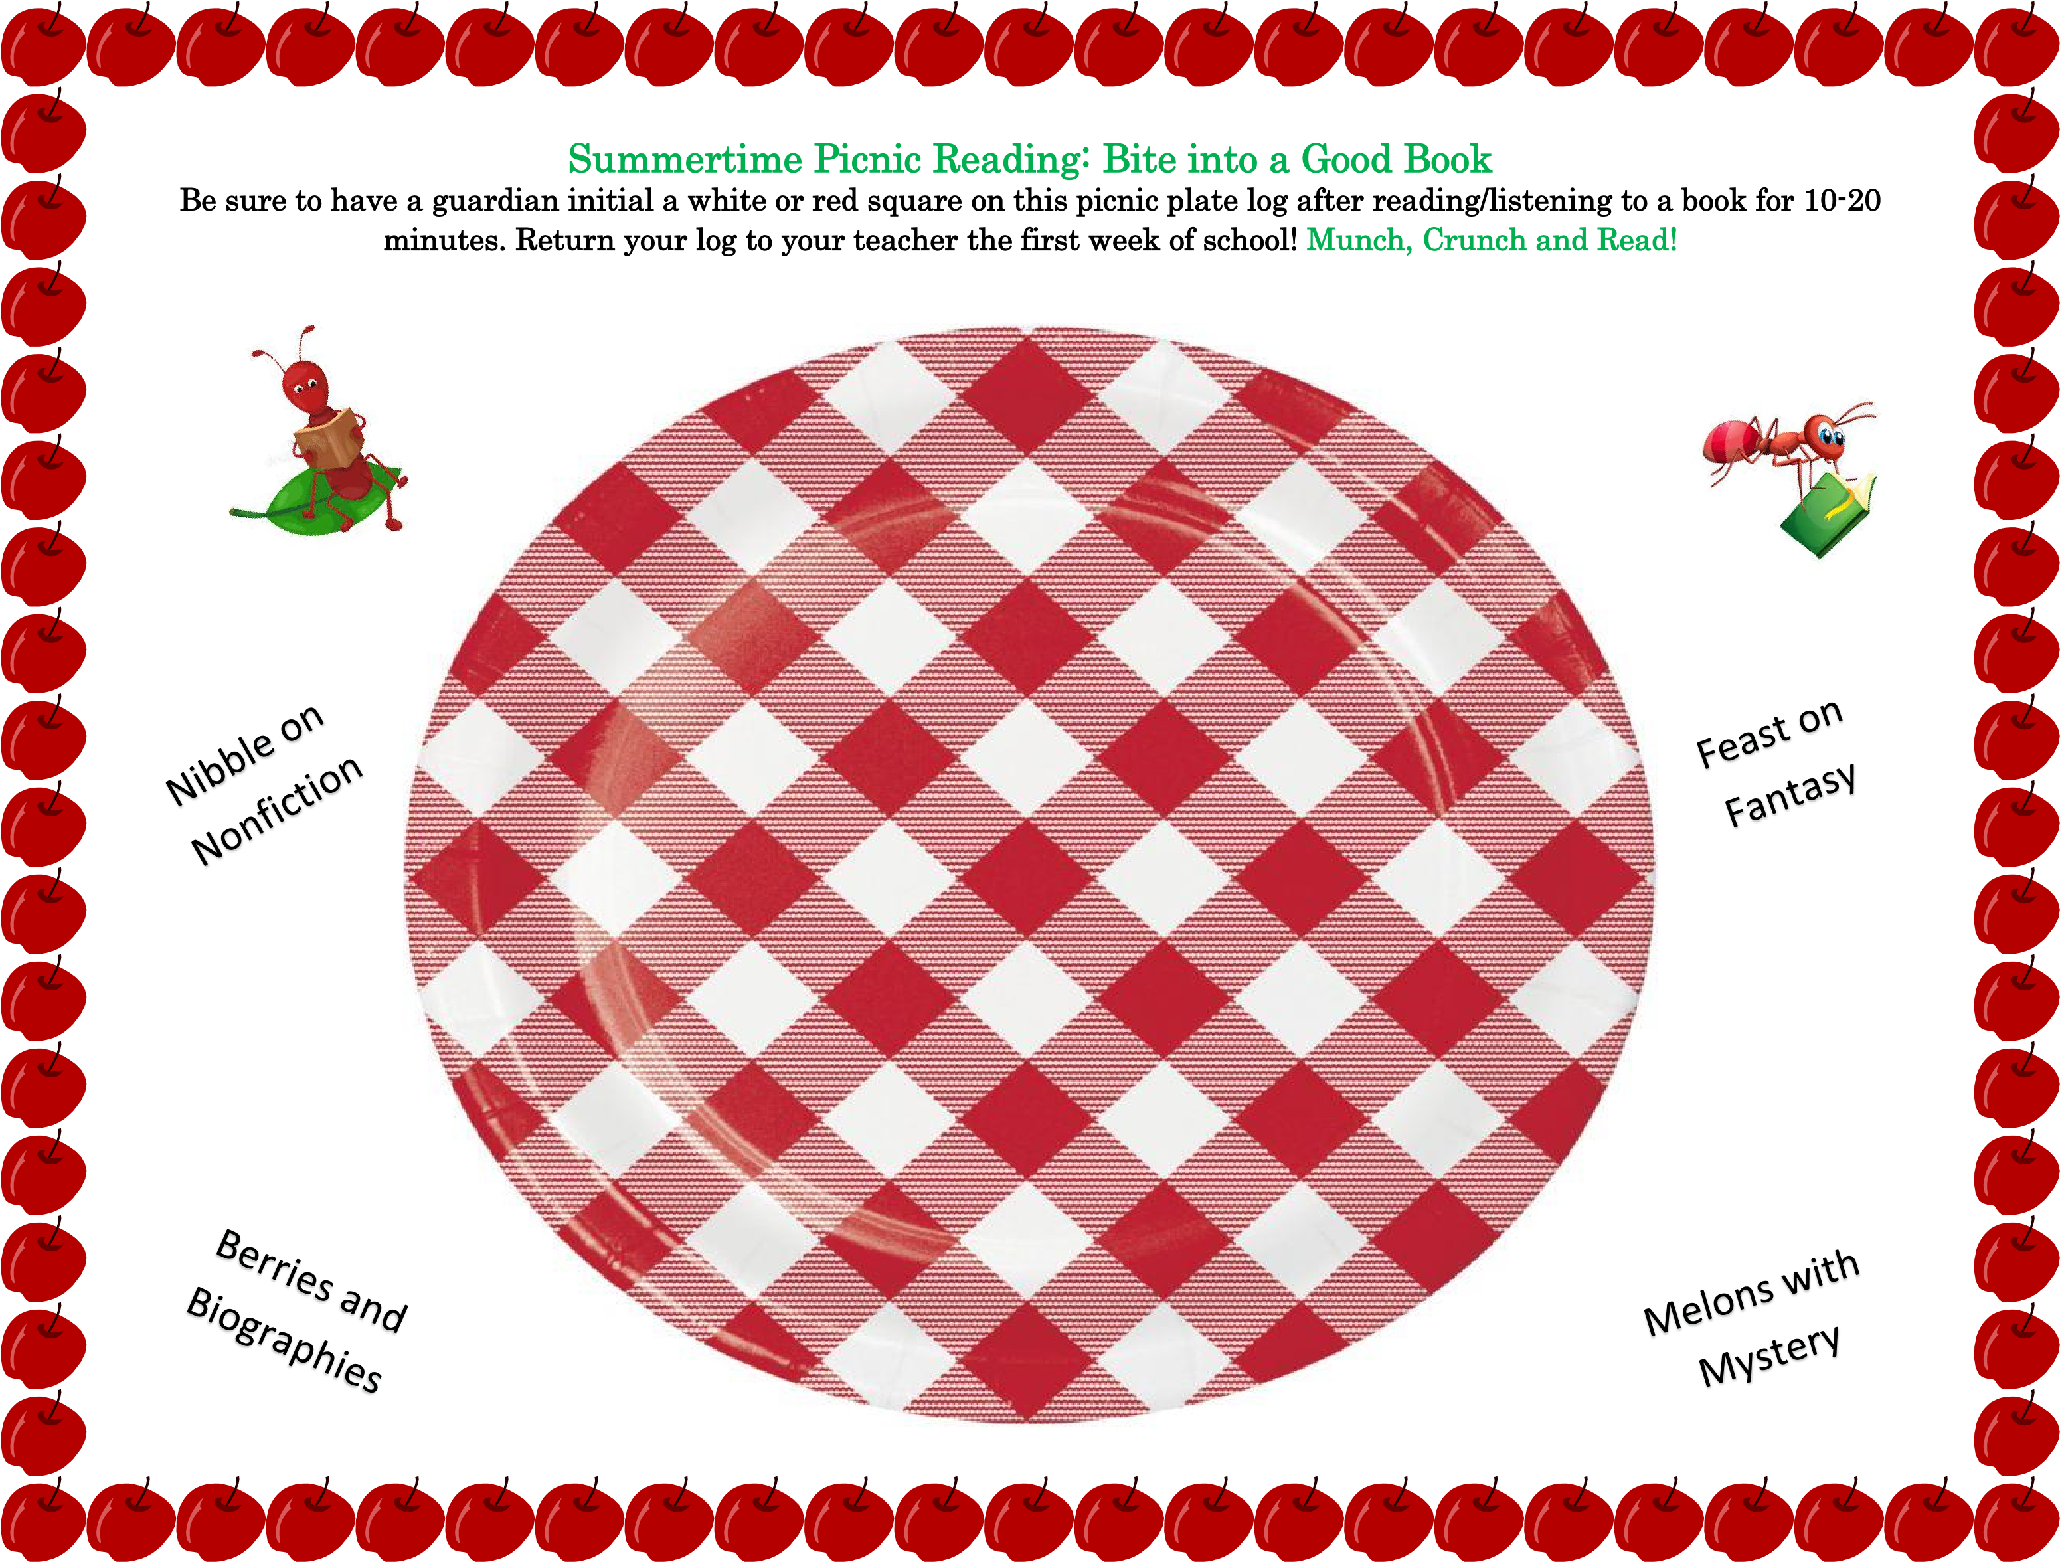

Teacher: ___________________

Name: ____________________

